BackyardMech
Garage and Mechanic Management System
System Requirements Specification
including Database Design
Version 1.0 — Draft
Prepared for: Randy Mauri (Owner, BackyardMech)
Prepared by: Dominic Panganiban
Date: July 31, 2026
This document derives from decisions already recorded in PROJECT-BRIEF and DECISIONS for the BackyardMech project. It does not introduce new scope; it documents and formalizes what has already been agreed, and adds the full database design.

Document Control
Field | Value
Document | BackyardMech — System Requirements Specification (SRS)
Version | 1.0 — Draft
Date | July 31, 2026
Status | Draft — for owner review before Stage 3 (Full Design) begins
Owner | Randy Mauri — BackyardMech
Source material | PROJECT-BRIEF, DECISIONS, TASKS (BackyardMech project files)

Revision History
Version | Date | Description
1.0 | 2026-07-31 | Initial draft, compiled from confirmed project decisions to date.

Table of Contents
(If this section looks empty, right-click it and choose "Update Field" — or select the whole document with Ctrl+A and press F9 — to generate the list of headings and page numbers. Word does this automatically on open in most default configurations.)
Document Control 2
Revision History 2
1. Introduction 5
1.1 Purpose 5
1.2 Scope 5
1.3 Intended Audience 5
1.4 Definitions & Acronyms 5
1.5 References 5
2. Overall Description 7
2.1 Product Perspective 7
2.2 User Roles & Characteristics 7
2.3 Operating Environment 7
2.4 Design & Implementation Constraints 7
2.5 Assumptions & Dependencies 7
3. Functional Requirements 8
3.1 Authentication & Role-Based Access Control 8
3.2 Customer & Vehicle Management 8
3.3 Appointments & Check-In 9
3.4 Service Queue & Workflow 9
3.5 Digital Inspection 9
3.6 Estimates & Customer Approval 9
3.7 Work Order & Assignment 10
3.8 Parts Management 10
3.9 Tools Management 10
3.10 Labour Time Tracking 10
3.11 Quality Control 11
3.12 Invoicing & Payments 11
3.13 Reporting 11
3.14 Audit Logging 11
4. Non-Functional Requirements 12
4.1 Security 12
4.2 Performance 12
4.3 Availability, Backup & Recovery 12
4.4 Usability & Responsiveness 12
4.5 Compliance 12
4.6 Maintainability & Architecture 13
5. System Architecture Overview 14
6. Database Design 15
6.1 Overview & Conventions 15
6.2 Identity & Audit 16
ApplicationUser (extends AspNetUsers) 16
AspNetRoles (standard Identity table) 16
AuditLogEntry 16
6.3 Core Service Workflow 17
Customer 17
Vehicle 18
Bay 18
Appointment 18
QueueStatusHistory 19
Inspection 20
InspectionMedia 20
Estimate 20
EstimateLineItem 20
WorkOrder 21
WorkOrderAssignment 21
QualityCheck 21
6.4 Labour, Parts & Tools 23
LabourEntry 23
LabourTimeSegment 24
Part 24
PartTransaction 24
Tool 26
ToolCheckout 26
6.5 Billing 27
TaxRate 27
Invoice 27
InvoiceLineItem 28
InvoiceAdjustment 28
7. Traceability to Project Files 29
8. Open Items & Assumptions 30
Appendix A: Glossary 31

1. Introduction

1.1 Purpose
This System Requirements Specification (SRS) defines what BackyardMech's garage and mechanic management system (Version 1) must do, how it must behave, and how its data is structured. It translates the requirements already agreed in the project's working files (PROJECT-BRIEF, DECISIONS) into a single, complete, structured reference — including the full database design — to guide the remaining design and build stages.

1.2 Scope
This document covers Version 1 of the system: a single-location garage management application handling the complete repair workflow from appointment or walk-in through to invoice, plus employee/role management, parts and tools tracking, and audit logging. It does not cover the customer portal, integrated card payment processing, a mobile app, or multi-branch administration — those are explicitly later phases (see PROJECT-BRIEF.md).

1.3 Intended Audience
- Randy Mauri — garage owner and sole developer, as the primary reader and decision-maker.
- Any future developer or contractor who joins the project, as onboarding reference.

1.4 Definitions & Acronyms
Term | Meaning
POC | Proof of Concept — the small, working slice of the system built in Stage 2 to validate the technology stack.
RBAC | Role-Based Access Control — restricting features by the signed-in user's assigned role(s).
SRS | System Requirements Specification — this document.
ERD | Entity-Relationship Diagram — a visual map of database tables and how they relate.
PK / FK | Primary Key / Foreign Key — the column(s) that uniquely identify a row, or reference another table's row.
HST | Harmonized Sales Tax — the combined federal/provincial sales tax used in Newfoundland and Labrador (currently 15%).
QC | Quality Control — the sign-off step confirming a repair was done correctly.
RPO / RTO | Recovery Point / Time Objective — how much data loss and downtime is acceptable after a failure.

1.5 References
- PROJECT-BRIEF — BackyardMech project brief (goals, workflow, roles, tech stack, security requirements)
- DECISIONS — running decisions log for the BackyardMech project
- TASKS — stage-by-stage task list for the BackyardMech project
- Canada Revenue Agency — GST/HST rates by province (accessed July 2026)
- Government of Newfoundland and Labrador — Harmonized Sales Tax (accessed July 2026)

2. Overall Description

2.1 Product Perspective
BackyardMech is a new, purpose-built system for an independent automotive repair garage in Newfoundland and Labrador. There is no existing system being replaced or migrated from. Version 1 supports a single garage location; the data model reserves room for additional locations later without a redesign.

2.2 User Roles & Characteristics
Role | Typical use of the system
Garage Owner | Full access; oversees the business, manages employees and roles.
Administrator | Manages employee accounts/roles; day-to-day system administration.
Service Advisor | Handles check-in, scheduling, estimates, and customer communication.
Mechanic / Technician | Performs inspections and repairs; records labour time and parts used.
Parts Clerk | Manages parts inventory: receiving, reservation, issue, returns.
Supervisor / QC Inspector | Signs off completed repairs before invoicing.
Accounting / Cashier | Handles invoicing, payments, and financial reporting.

2.3 Operating Environment
Version 1 is deployed on-premises, running on garage hardware (application and SQL Server 2025), with no Azure subscription required. The architecture is kept cloud-ready — file storage and any Azure-specific integrations sit behind abstractions — so a later migration to Azure is a configuration change, not a rewrite (see DECISIONS, 2026-07-31).

2.4 Design & Implementation Constraints
- Technology stack: C# / ASP.NET Core 10, EF Core 10, SQL Server 2025, ASP.NET Core Identity — matching Dominic's existing experience.
- Architecture: modular monolith using Clean Architecture, so business rules stay independent of ASP.NET Core/SQL Server-specific code.
- This is currently a solo build; the project proceeds one stage at a time, each reviewed before the next begins.

2.5 Assumptions & Dependencies
- The garage has (or will set up) a local server or workstation capable of running SQL Server 2025 and hosting the web application.
- Estimate/invoice delivery to customers depends on an email-sending capability, to be selected during Stage 3/4 design.
- Tax rate (15% NL HST) is current as of July 2026 and is stored as configurable, date-effective data rather than hard-coded, so future changes don't require a code change.

3. Functional Requirements
Each requirement has a unique ID for traceability. Priority reflects Version 1 scope: “Must” requirements are required for the definition of “done” in PROJECT-BRIEF.md; “Should” requirements are expected but could slip to a fast-follow update without blocking launch.

3.1 Authentication & Role-Based Access Control
ID | Requirement | Priority
FR-AUTH-01 | The system shall require employees to sign in with a unique account before accessing any staff functionality. | Must
FR-AUTH-02 | The system shall support seven staff roles: Garage Owner, Administrator, Service Advisor, Mechanic/Technician, Parts Clerk, Supervisor/QC Inspector, and Accounting/Cashier. | Must
FR-AUTH-03 | The system shall restrict each screen and action to the role(s) authorized to use it. | Must
FR-AUTH-04 | A Garage Owner or Administrator shall be able to assign or remove roles for any employee account. | Must
FR-AUTH-05 | A Garage Owner or Administrator shall be able to activate or deactivate an employee account without deleting its history. | Must
FR-AUTH-06 | The system shall lock an account for 15 minutes after 5 consecutive failed sign-in attempts. | Must
FR-AUTH-07 | The system shall support multi-factor authentication for privileged accounts. | Should — Stage 4 build item; not part of the Checkpoint 1 proof of concept.

3.2 Customer & Vehicle Management
ID | Requirement | Priority
FR-CUST-01 | The system shall allow staff to create and update customer records (name, contact information, address, notes). | Must
FR-CUST-02 | The system shall allow staff to associate one or more vehicles with a customer. | Must
FR-CUST-03 | The system shall record vehicle details: VIN, make, model, year, license plate, color, and odometer reading. | Must
FR-CUST-04 | The system shall maintain a complete, searchable repair and maintenance history per vehicle. | Must
FR-CUST-05 | The system shall allow staff to search customers and vehicles by name, phone, email, VIN, or license plate. | Must

3.3 Appointments & Check-In
ID | Requirement | Priority
FR-APPT-01 | The system shall allow staff to schedule a future appointment for a customer and vehicle. | Must
FR-APPT-02 | The system shall allow staff to register a walk-in customer directly into the queue. | Must
FR-APPT-03 | The system shall record who checked in each vehicle, and when. | Must
FR-APPT-04 | The system shall prevent double-booking a bay for overlapping appointment times. | Must

3.4 Service Queue & Workflow
ID | Requirement | Priority
FR-QUEUE-01 | The system shall track each vehicle through the following statuses, in order: Scheduled, Arrived, Inspection, Waiting for Approval, Waiting for Parts, Ready for Repair, In Bay, Quality Check, Ready for Pickup, Closed. | Must
FR-QUEUE-02 | The system shall display a real-time queue/work board showing every vehicle's current status, assigned mechanic, and bay. | Must
FR-QUEUE-03 | The system shall record every status change with a timestamp and the user who made it. | Must
FR-QUEUE-04 | The system shall allow a service advisor to assign an inspection mechanic and an available bay to a vehicle. | Must

3.5 Digital Inspection
ID | Requirement | Priority
FR-INSP-01 | The system shall allow a mechanic to record inspection notes, measurements, photos, and videos against a vehicle. | Must
FR-INSP-02 | The system shall record which mechanic performed each inspection, and when it started and completed. | Must
FR-INSP-03 | The system shall allow inspection findings to be used to build a repair estimate. | Must

3.6 Estimates & Customer Approval
ID | Requirement | Priority
FR-EST-01 | The system shall allow staff to create a cost estimate listing labour and parts line items. | Must
FR-EST-02 | The system shall email the customer a secure, time-limited link to review and approve or decline the estimate. | Must
FR-EST-03 | The system shall record the customer's approval or decline decision, with a timestamp. | Must
FR-EST-04 | The system shall support partial approval, where a customer approves some line items and declines others. | Must

3.7 Work Order & Assignment
ID | Requirement | Priority
FR-WO-01 | The system shall create a work order from an approved estimate. | Must
FR-WO-02 | The system shall allow one or more mechanics to be assigned to a work order. | Must
FR-WO-03 | The system shall prevent assigning a mechanic or bay to two overlapping work orders at the same time. | Must
FR-WO-04 | The system shall require quality-control sign-off by a mechanic or supervisor other than the one who performed the repair. | Must

3.8 Parts Management
ID | Requirement | Priority
FR-PART-01 | The system shall maintain a parts catalogue with SKU, description, cost, price, and quantity on hand. | Must
FR-PART-02 | The system shall allow parts to be reserved against a work order, then marked installed, returned, or wasted. | Must
FR-PART-03 | The system shall reduce on-hand quantity when parts are installed, and adjust it when parts are returned or wasted. | Must
FR-PART-04 | The system shall flag parts at or below their reorder threshold. | Should

3.9 Tools Management
ID | Requirement | Priority
FR-TOOL-01 | The system shall maintain a tool inventory with condition, location, and calibration/maintenance due dates. | Must
FR-TOOL-02 | The system shall record tool checkout and return against a mechanic and work order. | Must
FR-TOOL-03 | The system shall record a tool's condition at checkout and return, and flag damaged or missing tools. | Must

3.10 Labour Time Tracking
ID | Requirement | Priority
FR-LAB-01 | The system shall allow a mechanic to start, pause, resume, and complete labour time against a work order. | Must
FR-LAB-02 | The system shall calculate labour cost from recorded time and the mechanic's hourly rate. | Must

3.11 Quality Control
ID | Requirement | Priority
FR-QC-01 | The system shall record the outcome (pass/fail) of a quality check, who performed it, and when. | Must
FR-QC-02 | A failed quality check shall return the work order to an in-progress repair status, rather than allowing it to proceed to invoicing. | Must

3.12 Invoicing & Payments
ID | Requirement | Priority
FR-INV-01 | The system shall generate an invoice from a completed, quality-checked work order. | Must
FR-INV-02 | The system shall calculate tax using the currently effective, configurable tax rate (see NFR-COMPLY-01). | Must
FR-INV-03 | The system shall assign a unique, sequential invoice number. | Must
FR-INV-04 | The system shall prevent a finalized invoice from being silently edited; corrections require a recorded void, credit, or adjustment. | Must
FR-INV-05 | The system shall record payment against an invoice without storing card information. | Must

3.13 Reporting
ID | Requirement | Priority
FR-RPT-01 | The system shall produce reports covering sales, labour productivity, bay utilization, inventory value, low-stock parts, tool losses, and profitability. | Must

3.14 Audit Logging
ID | Requirement | Priority
FR-AUD-01 | The system shall automatically record every creation, change, and deletion of business data, including which user made the change and when. | Must
FR-AUD-02 | Audit log entries shall be viewable by an Administrator or Garage Owner. | Should

4. Non-Functional Requirements

4.1 Security
ID | Requirement
NFR-SEC-01 | Multi-factor authentication shall be available for privileged accounts (Stage 4 build item).
NFR-SEC-02 | Access shall be controlled by role- and permission-based authorization throughout.
NFR-SEC-03 | All traffic shall use HTTPS; data shall be encrypted in transit and at rest.
NFR-SEC-04 | All user input shall be validated server-side, regardless of client-side validation.
NFR-SEC-05 | The system shall be protected against SQL injection, cross-site scripting (XSS), and cross-site request forgery (CSRF).
NFR-SEC-06 | File uploads (inspection photos/videos) shall be validated for type and size before storage.
NFR-SEC-07 | The system shall apply rate limiting and account lockout to reduce brute-force sign-in attempts.
NFR-SEC-08 | The system shall never store customer payment card information.
NFR-SEC-09 | Dependencies shall be scanned regularly for known vulnerabilities.

4.2 Performance
ID | Requirement
NFR-PERF-01 | The queue board shall reflect a status change within a few seconds of it being made.
NFR-PERF-02 | Common screens (queue board, customer/vehicle search) shall load within 2 seconds under normal on-premises load, for the single-location scale of Version 1.

4.3 Availability, Backup & Recovery
ID | Requirement
NFR-AVAIL-01 | Backups shall be automated and encrypted, with a 15-minute recovery point objective (RPO).
NFR-AVAIL-02 | The system shall be restorable after a failure within a 4-hour recovery time objective (RTO).

4.4 Usability & Responsiveness
ID | Requirement
NFR-USE-01 | The application shall be usable on desktop, tablet, and phone screen sizes.
NFR-USE-02 | The interface shall use plain, consistent language appropriate for garage staff who are not necessarily technical.

4.5 Compliance
ID | Requirement
NFR-COMPLY-01 | The system shall support configurable, date-effective Canadian GST/HST rates. Current default: 15% for Newfoundland and Labrador (5% federal GST + 10% provincial), verified July 2026 against the Canada Revenue Agency and the Government of Newfoundland and Labrador.
NFR-COMPLY-02 | Invoice numbering shall be sequential and gap-free, consistent with standard accounting practice.

4.6 Maintainability & Architecture
ID | Requirement
NFR-ARCH-01 | The system shall be built as a modular monolith using Clean Architecture, keeping business rules independent of ASP.NET Core/SQL Server-specific code.
NFR-ARCH-02 | The system shall be deployable on-premises for Version 1, with no code changes required to later migrate to Azure — only configuration.

5. System Architecture Overview
BackyardMech is built as a modular monolith using Clean Architecture: one deployable application, internally layered so business rules don't depend directly on ASP.NET Core or SQL Server. This keeps the door open for change — including the future Azure migration — without a rewrite.
Layer / Area | Technology
Architecture | Modular monolith with Clean Architecture (Domain, Application, Infrastructure, Web)
Backend | C# with ASP.NET Core 10
User interface | ASP.NET Core MVC/Razor with Bootstrap
Database access | Entity Framework Core 10
Database (Version 1) | SQL Server 2025, on-premises on garage hardware
Authentication | ASP.NET Core Identity
Authorization | Role- and policy-based permissions
Hosting (Version 1) | On-premises — no Azure subscription required
Hosting (future) | Cloud-ready for migration to Azure (Azure SQL Database, Blob Storage, App Service)
File storage | Local storage for Version 1, behind an abstraction for a later Azure Blob Storage swap
Source control | Git (Azure DevOps or GitHub)
Testing | xUnit, integration tests, browser-based UI tests
Monitoring | Structured logging, health checks, application monitoring
Full rationale for each of these choices is recorded in DECISIONS (entries dated 2026-07-30 and 2026-07-31).

6. Database Design

6.1 Overview & Conventions
The database is SQL Server 2025, accessed through Entity Framework Core 10. Tables fall into four groups, shown as three diagrams below (Identity/Audit tables are described in text, since two of them — the user and role tables — are largely generated automatically by ASP.NET Core Identity): Identity & Audit; Core Service Workflow; Labour, Parts & Tools; and Billing.
Conventions used throughout the tables below:
- PK = Primary Key. FK = Foreign Key (references another table's PK).
- All tables include this project's automatic audit trail via the AuditLogEntries table (see 6.2) — individual tables do not repeat "created by / modified by" columns unless noted, since the audit log already captures who changed what and when.
- Money columns use decimal(18,2). Timestamps use datetime2 and are stored in UTC.
- This design matches the entities described in PROJECT-BRIEF.md's "What the system must track" section and the Checkpoint 1 proof-of-concept code already delivered (Domain/Infrastructure projects).

6.2 Identity & Audit
User accounts and roles are managed by ASP.NET Core Identity, which generates its own standard tables (AspNetUsers, AspNetRoles, AspNetUserRoles, and related tables for logins/claims/tokens). BackyardMech extends the standard user table with a small number of extra columns, and adds one custom table for the audit trail.

ApplicationUser (extends AspNetUsers)
The standard Identity user table, plus:
Column | Type | Key | Description
Id | nvarchar(450) | PK | Identity-generated unique user ID (unchanged from the standard table).
DisplayName | nvarchar(200) |  | Full name shown in the UI, separate from the login email.
IsActive | bit |  | Lets an administrator deactivate a former employee's account without deleting their history.
CreatedUtc | datetime2 |  | When the account was created.

AspNetRoles (standard Identity table)
Holds the seven fixed BackyardMech roles: Garage Owner, Administrator, Service Advisor, Mechanic/Technician, Parts Clerk, Supervisor/QC Inspector, Accounting/Cashier. AspNetUserRoles links users to one or more of these roles.

AuditLogEntry
Written automatically whenever any tracked entity in the database is created, changed, or deleted — this is already implemented in the Checkpoint 1 proof-of-concept code, so every table added in later checkpoints gets audit coverage for free.
Column | Type | Key | Description
Id | bigint | PK | Auto-incrementing row ID.
UserId | nvarchar(450) | FK | The signed-in user who made the change, if known.
UserName | nvarchar(256) |  | Snapshot of the user's name at the time, kept even if the account is later renamed.
Action | nvarchar(50) |  | "Created", "Updated", or "Deleted".
EntityName | nvarchar(200) |  | The type of record that changed, e.g. "Vehicle".
EntityId | nvarchar(100) |  | The primary key of the affected record, as text.
TimestampUtc | datetime2 |  | When the change happened.
Details | nvarchar(max) |  | JSON snapshot of the record's values at the time of the change.

6.3 Core Service Workflow
Covers a vehicle's journey from customer/vehicle record through appointment, inspection, estimate, and into a work order — the heart of the day-to-day workflow described in PROJECT-BRIEF.
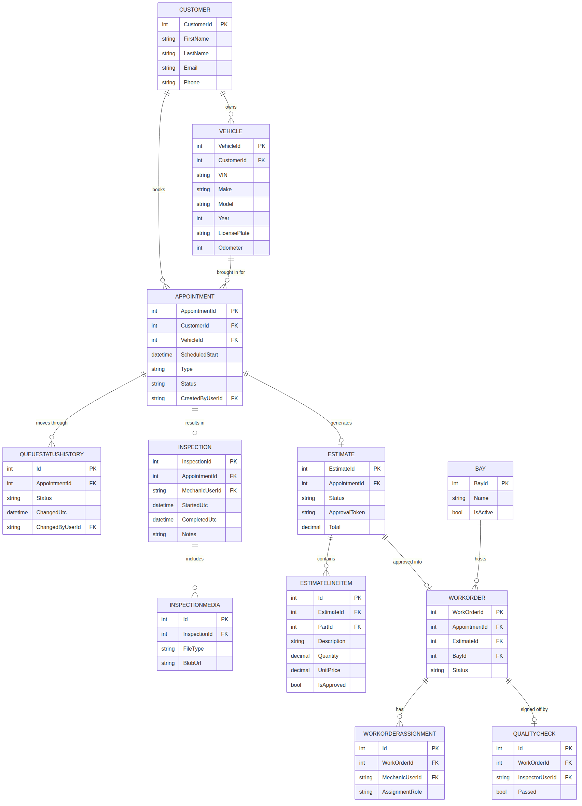
Figure 1 — Core Service Workflow entity-relationship diagram

Customer
Column | Type | Key | Description
CustomerId | int | PK | Auto-incrementing ID.
FirstName | nvarchar(100)
LastName | nvarchar(100)
Email | nvarchar(256)
Phone | nvarchar(30)
Address / City / Province / PostalCode | nvarchar |  | Mailing address, split into separate columns.
Notes | nvarchar(max) |  | Free-text notes.
CreatedUtc | datetime2

Vehicle
Column | Type | Key | Description
VehicleId | int | PK
CustomerId | int | FK | References Customer — the owner.
VIN | nvarchar(17) |  | Vehicle identification number.
Make / Model | nvarchar(100)
Year | int
LicensePlate | nvarchar(20)
Color | nvarchar(50)
Odometer | int |  | Most recent recorded reading, in kilometres.
CreatedUtc | datetime2

Bay
Column | Type | Key | Description
BayId | int | PK
Name | nvarchar(50) |  | e.g. "Bay 1".
Description | nvarchar(200) |  | Optional — e.g. equipment available in that bay.
IsActive | bit |  | Lets a bay be taken out of service without deleting its history.

Appointment
Represents both scheduled appointments and walk-ins (distinguished by the Type column).
Column | Type | Key | Description
AppointmentId | int | PK
CustomerId | int | FK
VehicleId | int | FK
ScheduledStart / ScheduledEnd | datetime2 |  | For walk-ins, set to the actual arrival time.
Type | nvarchar(20) |  | "Appointment" or "WalkIn".
Status | nvarchar(30) |  | Current queue status (see FR-QUEUE-01 for the full list).
CreatedByUserId | nvarchar(450) | FK | Staff member who created the record.
Notes | nvarchar(max)
CreatedUtc | datetime2

QueueStatusHistory
One row per status change, giving a full audit trail of a vehicle's movement through the queue (FR-QUEUE-03).
Column | Type | Key | Description
Id | int | PK
AppointmentId | int | FK
Status | nvarchar(30) |  | The status being entered.
ChangedUtc | datetime2
ChangedByUserId | nvarchar(450) | FK
Notes | nvarchar(max) |  | Optional context for the change.

Inspection
Column | Type | Key | Description
InspectionId | int | PK
AppointmentId | int | FK
MechanicUserId | nvarchar(450) | FK | Mechanic who performed the inspection.
StartedUtc / CompletedUtc | datetime2
Notes | nvarchar(max) |  | Findings, measurements described in text.

InspectionMedia
Column | Type | Key | Description
Id | int | PK
InspectionId | int | FK
FileType | nvarchar(20) |  | "Photo" or "Video".
BlobUrl | nvarchar(500) |  | Path/URL to the stored file (local storage in V1; see NFR-ARCH-02).
UploadedUtc | datetime2
UploadedByUserId | nvarchar(450) | FK

Estimate
Column | Type | Key | Description
EstimateId | int | PK
AppointmentId | int | FK
Status | nvarchar(20) |  | Draft / Sent / Approved / PartiallyApproved / Declined / Expired.
ApprovalToken | uniqueidentifier |  | Secure token embedded in the customer's approval link.
ApprovalTokenExpiresUtc | datetime2
SentToCustomerUtc / RespondedUtc | datetime2
Subtotal / TaxAmount / Total | decimal(18,2)
CreatedByUserId | nvarchar(450) | FK

EstimateLineItem
Column | Type | Key | Description
Id | int | PK
EstimateId | int | FK
PartId | int | FK (nullable) | Set when the line item is a part rather than labour.
Description | nvarchar(300)
LineType | nvarchar(20) |  | "Labour" or "Part".
Quantity | decimal(18,2)
UnitPrice / LineTotal | decimal(18,2)
IsApproved | bit |  | Supports partial approval (FR-EST-04).

WorkOrder
Column | Type | Key | Description
WorkOrderId | int | PK
AppointmentId | int | FK
EstimateId | int | FK (nullable)
BayId | int | FK
Status | nvarchar(30) |  | Mirrors the relevant portion of the queue status list.
ScheduledStart / ScheduledEnd | datetime2
ActualStart / ActualEnd | datetime2
CreatedUtc | datetime2

WorkOrderAssignment
Column | Type | Key | Description
Id | int | PK
WorkOrderId | int | FK
MechanicUserId | nvarchar(450) | FK
AssignmentRole | nvarchar(30) |  | e.g. "PrimaryMechanic", "Supervisor".
AssignedUtc | datetime2

QualityCheck
Column | Type | Key | Description
Id | int | PK
WorkOrderId | int | FK
InspectorUserId | nvarchar(450) | FK | Must differ from the mechanic(s) who performed the repair (FR-WO-04).
Passed | bit
PerformedUtc | datetime2
Notes | nvarchar(max)

6.4 Labour, Parts & Tools
Covers time tracking on a work order, and the two different inventory models: parts are consumed; tools are checked out and returned.
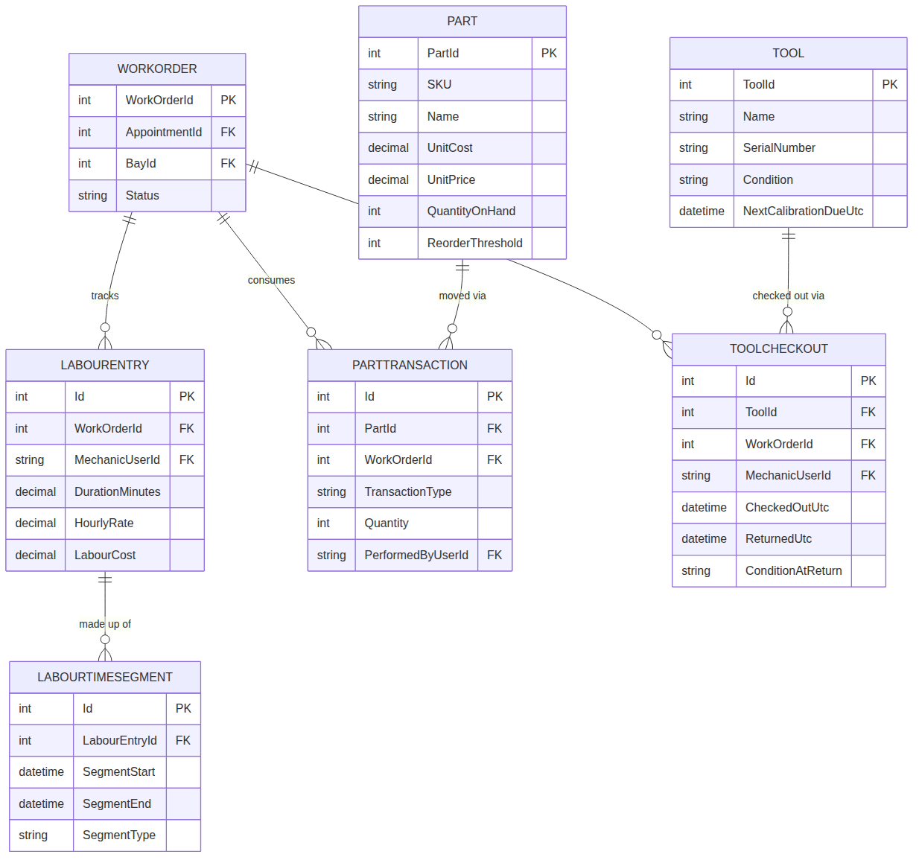
Figure 2 — Labour, Parts & Tools entity-relationship diagram

LabourEntry
Column | Type | Key | Description
Id | int | PK
WorkOrderId | int | FK
MechanicUserId | nvarchar(450) | FK
DurationMinutes | decimal(18,2) |  | Total worked time, computed from LabourTimeSegment rows.
HourlyRate | decimal(18,2) |  | Snapshot of the mechanic's rate at the time of work.
LabourCost | decimal(18,2) |  | DurationMinutes × HourlyRate ÷ 60.
Notes | nvarchar(max)

LabourTimeSegment
Individual start/pause/resume/complete segments — supports FR-LAB-01 without losing the detail of interruptions.
Column | Type | Key | Description
Id | int | PK
LabourEntryId | int | FK
SegmentStart / SegmentEnd | datetime2 |  | SegmentEnd is null while work is in progress.
SegmentType | nvarchar(20) |  | "Work" or "Pause".

Part
Column | Type | Key | Description
PartId | int | PK
SKU | nvarchar(50)
Name / Description | nvarchar
Category | nvarchar(100)
UnitCost / UnitPrice | decimal(18,2)
QuantityOnHand | int
ReorderThreshold | int |  | Triggers the low-stock flag (FR-PART-04).
Supplier | nvarchar(200)
IsActive | bit

PartTransaction
Every movement of a part is recorded as a transaction, rather than just adjusting the on-hand count directly — this preserves a full history.
Column | Type | Key | Description
Id | int | PK
PartId | int | FK
WorkOrderId | int | FK (nullable) | Null for a pure inventory transaction (e.g. received stock).
TransactionType | nvarchar(20) |  | Received / Reserved / Installed / Returned / Wasted / Adjustment.
Quantity | int |  | Positive or negative, depending on TransactionType.
UnitCostAtTransaction | decimal(18,2)
PerformedByUserId | nvarchar(450) | FK
PerformedUtc | datetime2
Notes | nvarchar(max)

Tool
Column | Type | Key | Description
ToolId | int | PK
Name | nvarchar(150)
SerialNumber | nvarchar(100)
Category | nvarchar(100)
Location | nvarchar(100)
Condition | nvarchar(30) |  | e.g. Good / Needs Service / Damaged.
LastCalibratedUtc / NextCalibrationDueUtc | datetime2
IsActive | bit

ToolCheckout
Column | Type | Key | Description
Id | int | PK
ToolId | int | FK
WorkOrderId | int | FK (nullable)
MechanicUserId | nvarchar(450) | FK
CheckedOutUtc / ReturnedUtc | datetime2 |  | ReturnedUtc is null while the tool is out.
ConditionAtCheckout / ConditionAtReturn | nvarchar(30)
IsDamagedOrMissing | bit |  | Flags for follow-up (FR-TOOL-03).
Notes | nvarchar(max)

6.5 Billing
Covers invoicing, tax calculation, and the correction model that keeps finalized invoices from being silently edited (FR-INV-04).
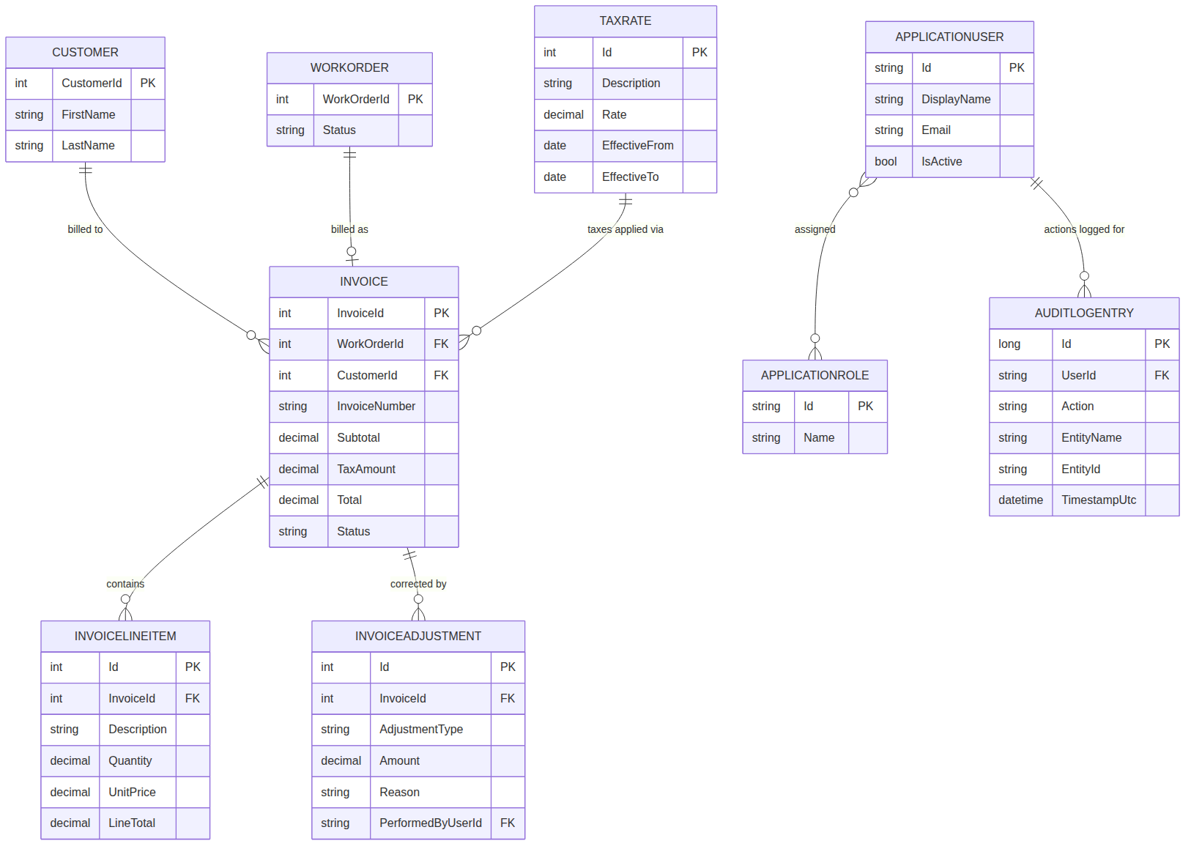
Figure 3 — Billing, Identity & Audit entity-relationship diagram

TaxRate
The configurable, date-effective tax table referenced in NFR-COMPLY-01 and DECISIONS.md (2026-07-31).
Column | Type | Key | Description
Id | int | PK
Description | nvarchar(100) |  | e.g. "NL HST".
Rate | decimal(6,4) |  | e.g. 0.1500 for 15%.
EffectiveFrom | date
EffectiveTo | date |  | Null if still current.

Invoice
Column | Type | Key | Description
InvoiceId | int | PK
WorkOrderId | int | FK
CustomerId | int | FK
InvoiceNumber | nvarchar(30) |  | Sequential, gap-free (NFR-COMPLY-02).
IssuedUtc | datetime2
TaxRateId | int | FK | References the TaxRate row applied.
Subtotal / TaxAmount / Total | decimal(18,2)
Status | nvarchar(20) |  | Open / Paid / Void / Credited.
PaidUtc | datetime2
PaymentMethod | nvarchar(30) |  | No card numbers are ever stored (NFR-SEC-08).

InvoiceLineItem
Column | Type | Key | Description
Id | int | PK
InvoiceId | int | FK
Description | nvarchar(300)
SourceType | nvarchar(20) |  | "Labour" or "Part".
Quantity / UnitPrice / LineTotal | decimal(18,2)

InvoiceAdjustment
Any correction to a finalized invoice is a new row here, never an edit to the original invoice or its line items (FR-INV-04).
Column | Type | Key | Description
Id | int | PK
InvoiceId | int | FK
AdjustmentType | nvarchar(20) |  | Void / Credit / Adjustment.
Amount | decimal(18,2)
Reason | nvarchar(300)
PerformedByUserId | nvarchar(450) | FK
PerformedUtc | datetime2

7. Traceability to Project Files
Every requirement in this document traces back to a source already agreed in the BackyardMech project's working files, rather than introducing new scope on its own:
Section here | Source
Section 2 (Overall Description) | PROJECT-BRIEF.md — Overview, Client, Users, Development approach
Section 3 (Functional Requirements) | PROJECT-BRIEF.md — Core workflow, Users, What the system must track
Section 4 (Non-Functional Requirements) | PROJECT-BRIEF.md — Security requirements, Definition of "done"
Section 5 (Architecture) | PROJECT-BRIEF.md — Technology stack; DECISIONS.md (2026-07-30, 2026-07-31)
Section 6 (Database Design) | New in this document — first full data model, built from the tracking requirements and workflow already agreed

8. Open Items & Assumptions
Carried over from PROJECT-BRIEF, plus items this document's detail level surfaced:
- Full Stage 3 design (screens, detailed authorization policies per screen) will refine, not replace, the data model in Section 6 — some columns may be added as screens are designed in detail.
- Email delivery mechanism for estimate/invoice links (FR-EST-02) is not yet selected — needed before Checkpoint 2/3 of the proof of concept can fully demonstrate the approval workflow.
- Multi-factor authentication (NFR-SEC-01 / FR-AUTH-07) is deferred to Stage 4 build, as agreed.
- This is a draft (Version 1.0) for Dominic's review — treat requirement wording as a starting point to correct, not a final specification.

Appendix A: Glossary
Term | Meaning
Work order | The authorized repair job created once a customer approves an estimate.
Bay | A physical service bay in the garage where repair work is performed.
Line item | A single billable entry (one part or one labour charge) on an estimate or invoice.
On-premises | Running on hardware physically located at the garage, rather than in the cloud.
Modular monolith | One deployable application, internally organized into independent modules/layers.
Configurable, date-effective rate | A value (like a tax rate) stored in the database with a start date, so it can change over time without a code deployment.

